Prep to 2 Learning Grid - Week 2
Favourite Toy  Draw your favourite toy. Write some sentences about your favourite toy. For example..  My toy is... I like it because…  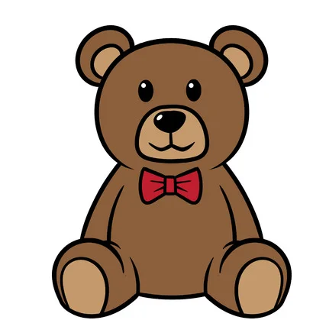  Label the drawing of your favourite toy.  Write some sentences describing what your toy looks like and why you like it. | Hide and Seek  Hide your favourite toy and then give directions to your parent or brother/sister to find it. Use positional language to describe where things are e.g. Between, above, under etc | Inside obstacle course  Can you create an obstacle course in your lounge room?  Don’t forget to ask first, and pack things away afterwards. | Money box or wallet?  Do you have a money box or a wallet?  Empty out the contents and count up your money.  Get a family member to help if you need to.
Pattern hunt  Look for different patterns in your house.  How many different patterns can you find?  What is your favourite pattern? - can you draw it in your workbook? | Beginning-Middle-End  Have a parent or a sister/brother read your favourite book to you or read it yourself.  Draw or write some sentences about the beginning, middle and end of your favourite storybook and retell it to your family member. | How many steps?  How many steps is it from your bedroom to the kitchen?  How many steps is it from the bathroom to the lounge room?  Record your steps then ask a family member to count thiers. Is it a different number? Can you make yours a different amount of steps? | BOOK TIME  Read your favorite book aloud in a silly voice!  Will you be a robot?  Will you be a pirate?  Will you be a whale?  Can you make someone laugh with your silly voice?
Family Fun  Write a story together.  Find someone in your family and take it in turns to write the sentences in a story. | Fort time!  Ask permission first…  Build a blanket and pillow fort. Can you fit inside? Or is it a small fort just for your toys?  Draw a picture of your fort in your workbook.  Don’t forget to pack up after. | What can you see?  Do you have a tree in your yard that is safe to climb?  What can you see? What can you hear?  Record your discoveries in your workbook. | Colour Food Hunt  Go on a rainbow food hunt. Make tallies of how many different colours you find.  Before you start, predict what colour food you think you will find the most of. Add all your tallies for each colour at the end of your food hunt to see which colour food was the most popular.

