3/4 At Home Learning - Grid #2
Reading  Quietly read to yourself for 15 minutes, stopping and checking for your understanding after every chapter or at the end of the book. | Writing  For the time that you are at home, keep a diary. Write a paragraph a day about what is happening in your life, how you’re feeling, why you feel that way and any other things you would like to write about your life. | Reading  Learn three new jokes and share them with the people who live with you. Get them to give you a score out of 10 for each joke. What was your score? | Writing  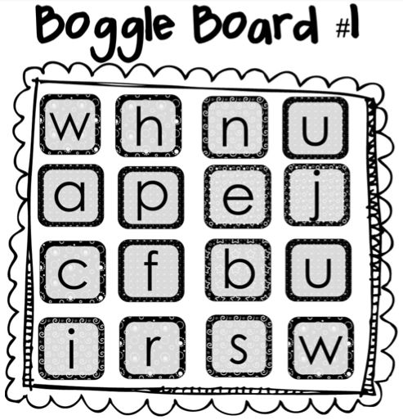  How many words can you make using the letters on the Boggle board?  Rule: You can only use each letter as many times as it is on the board in each word e.g.  I can’t make wishes because there is only one ‘s’
Writing/ Reading  Choose your favourite book character and draw a colourful picture of that character. Once you’ve drawn your picture, write down THREE sentences describing the things you admire about your character e.g.  I admire Hermione Granger because she is an intelligent and strong female character. | Maths  Using any or all of the below numbers and any of the math operations such as (+,-, X). How many ways can you get to the number?  164  50 2 5 6 8 3  You can also make it easier and create a 2 digit number, or harder and make a 4 digit number. |  | Maths  Kakuro is a math crossword puzzle where you use the numbers 1 through 9 to add and total “clues” on the outside row. 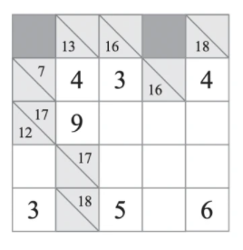
Maths  Using the below shapes, or you could add more, try and find items around the house that match these shapes. For each correct matched shape you get one point.  Challenge: Set a time limit of 5 or 10 minutes and extra points awarded for more irregular shapes such as parallelograms. Can you name the shapes below?  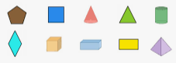 |  | Wellbeing  Have a go at a Cosmic Kids Yoga session on Youtube. How did you go with it? | Wellbeing  Lay on the ground and look at the clouds. Do you know the names of any clouds? Do they look like any patterns or pictures? Could you draw a picture of some of them?

